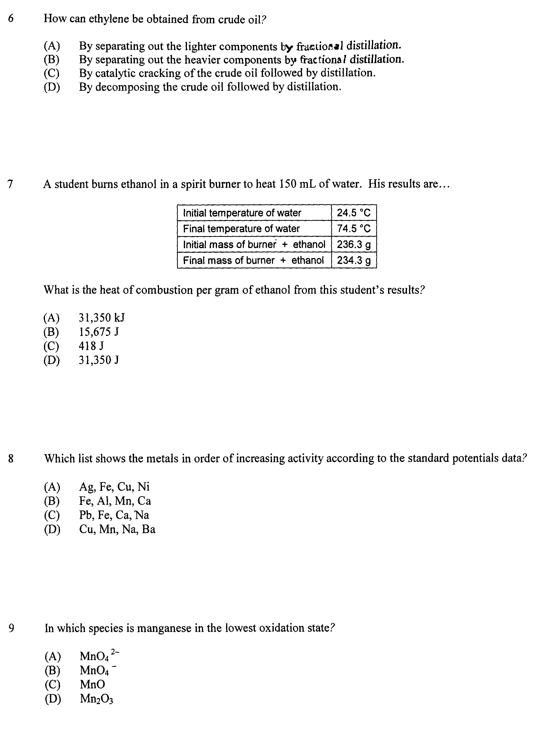

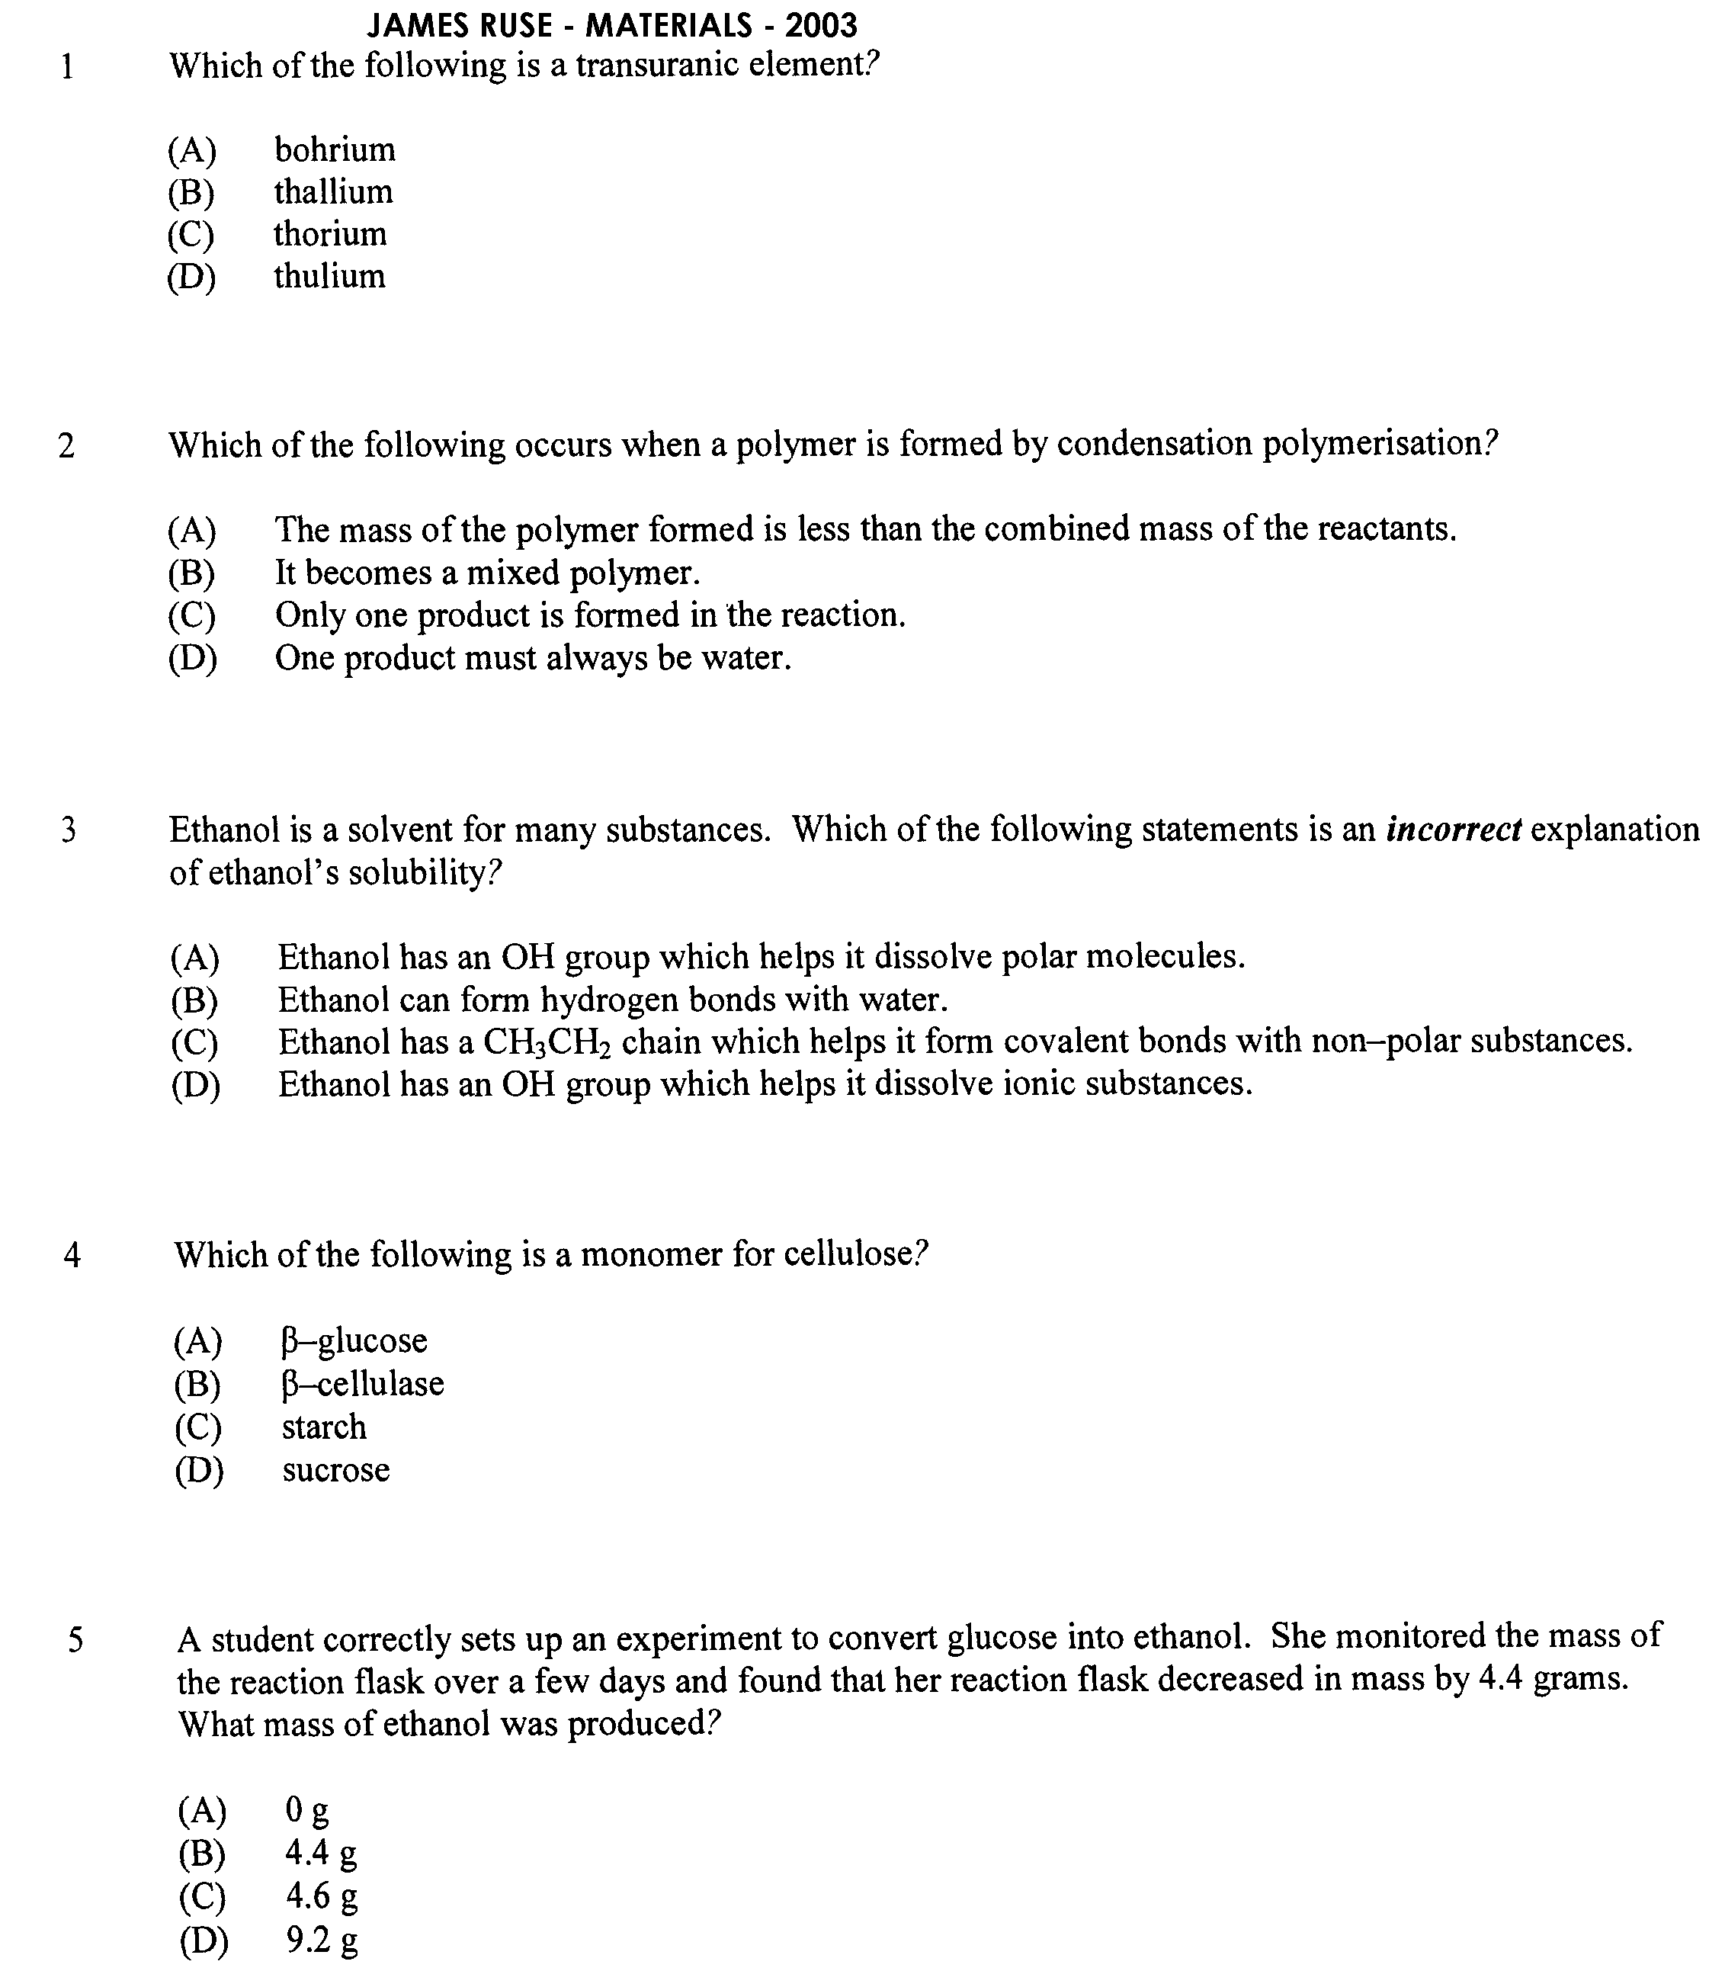

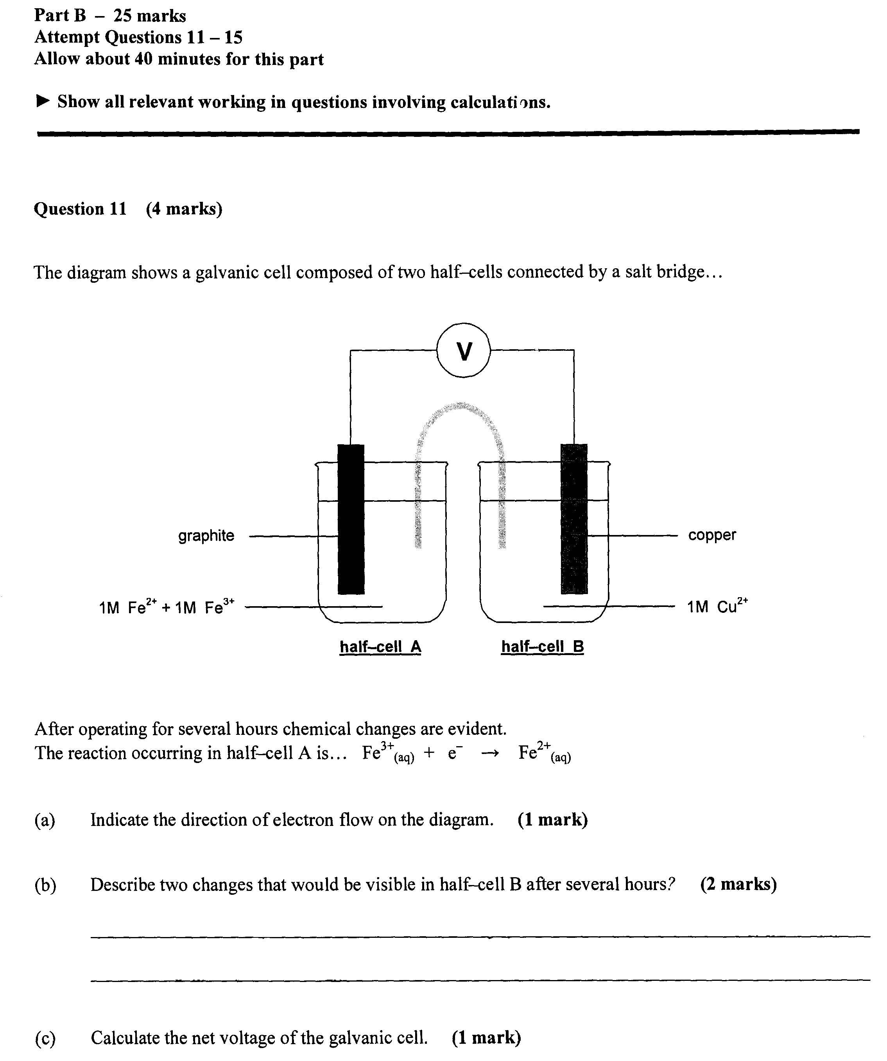

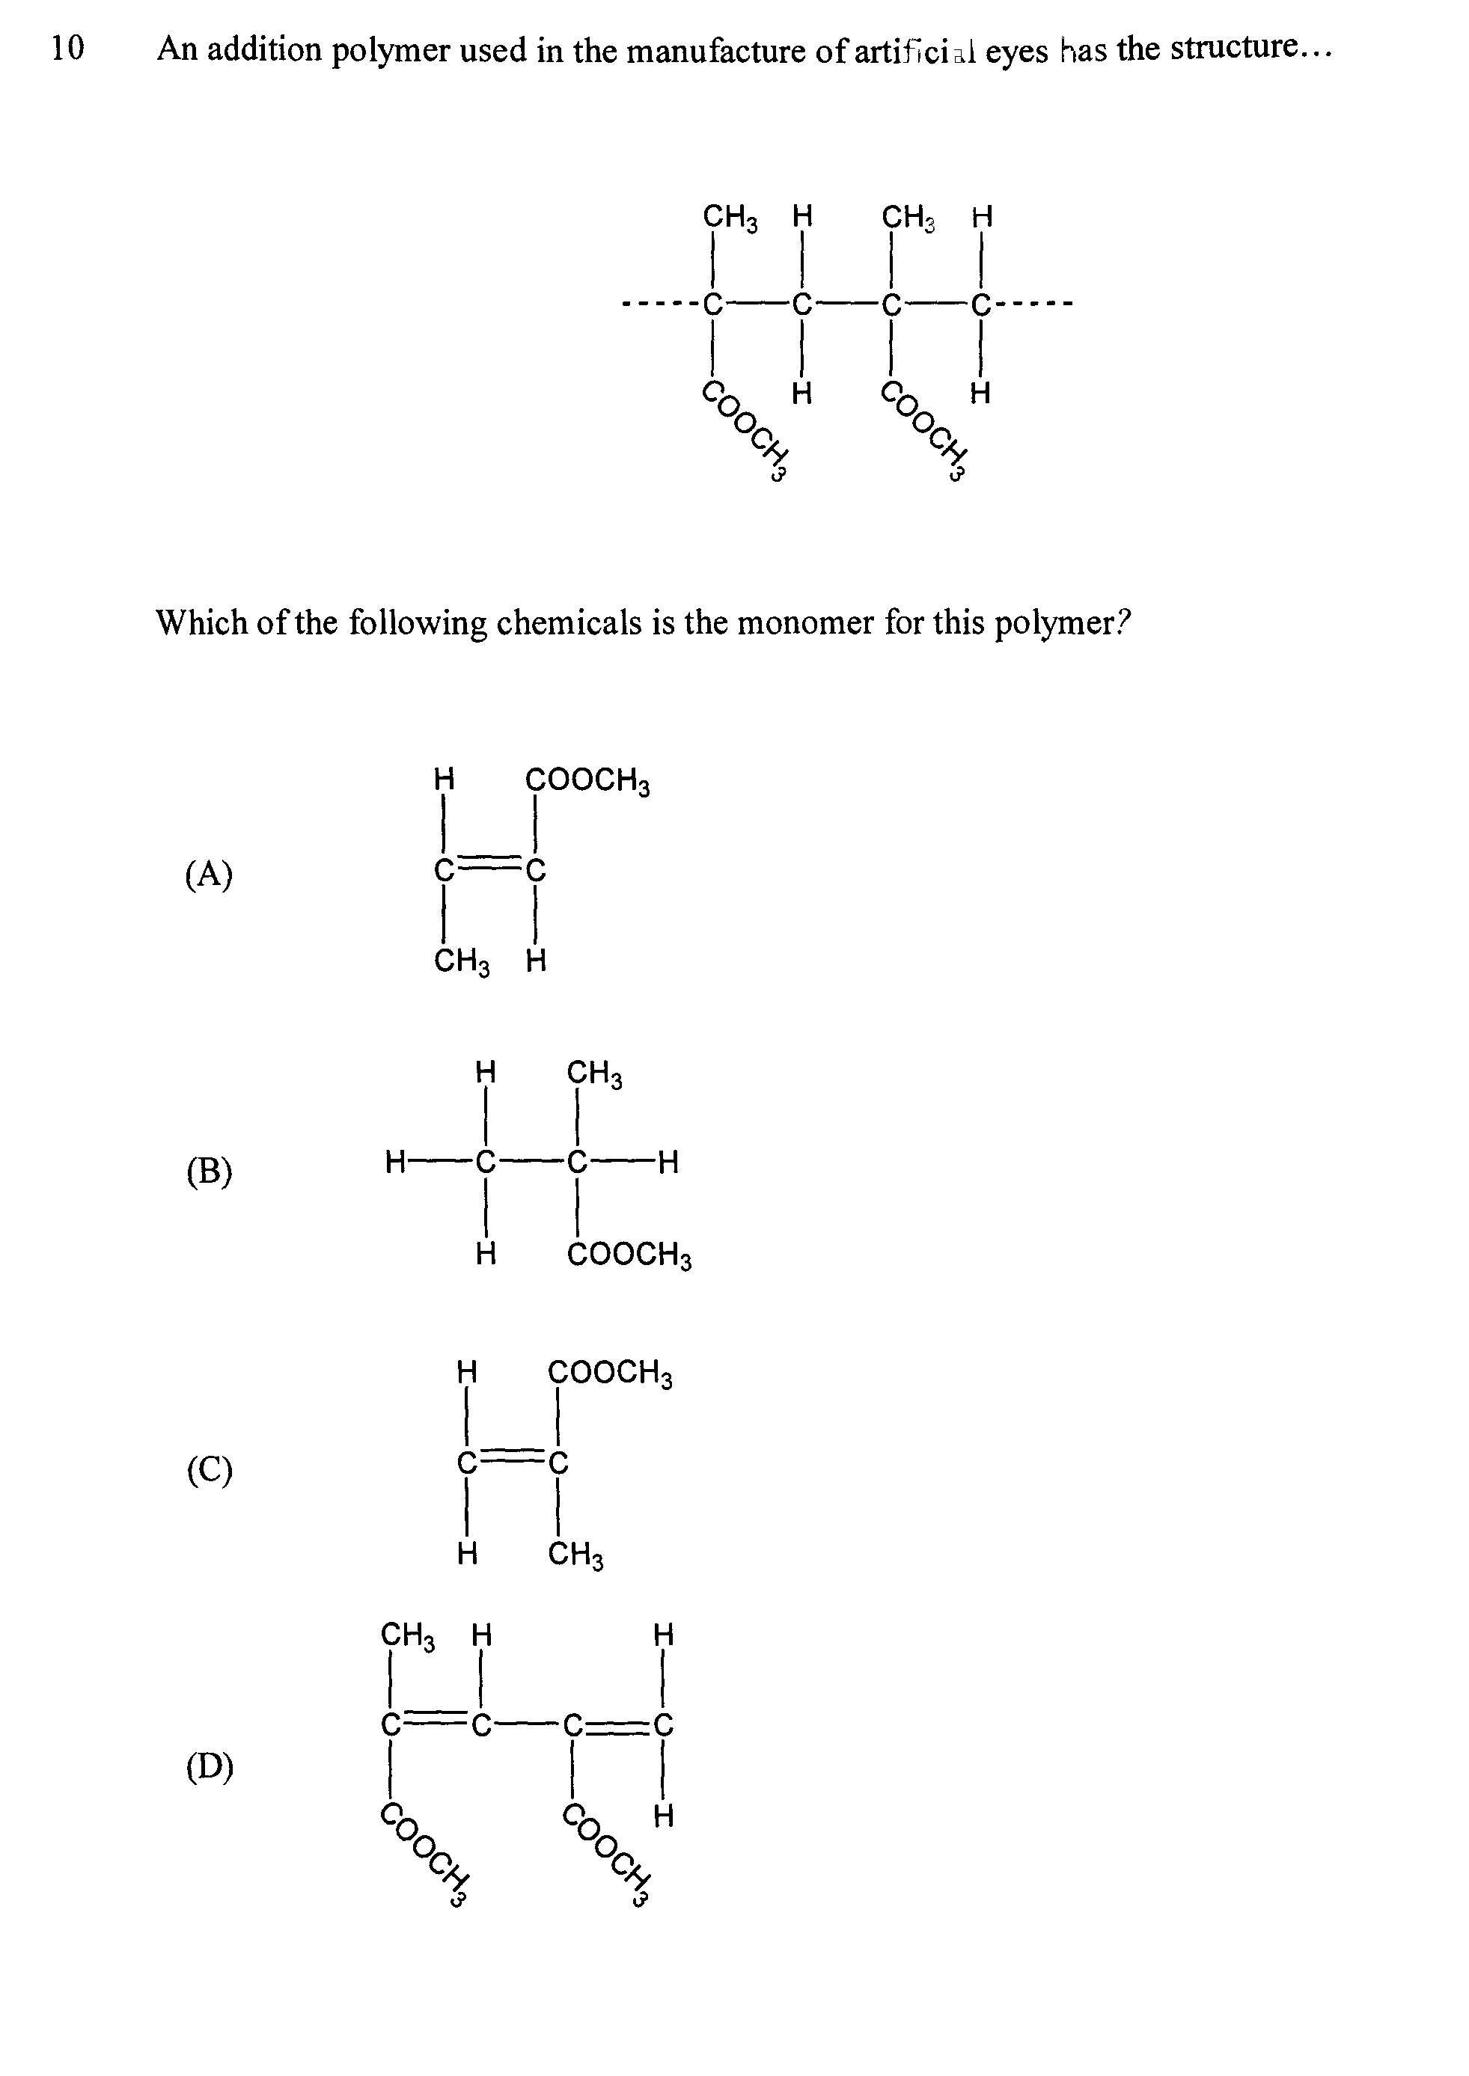

**Question 12 (9 marks)**

Identify the type of reaction (A, B, C & D) in the flow chart and write a balanced chemical equation

for each reaction. (include states of matter and conditions)

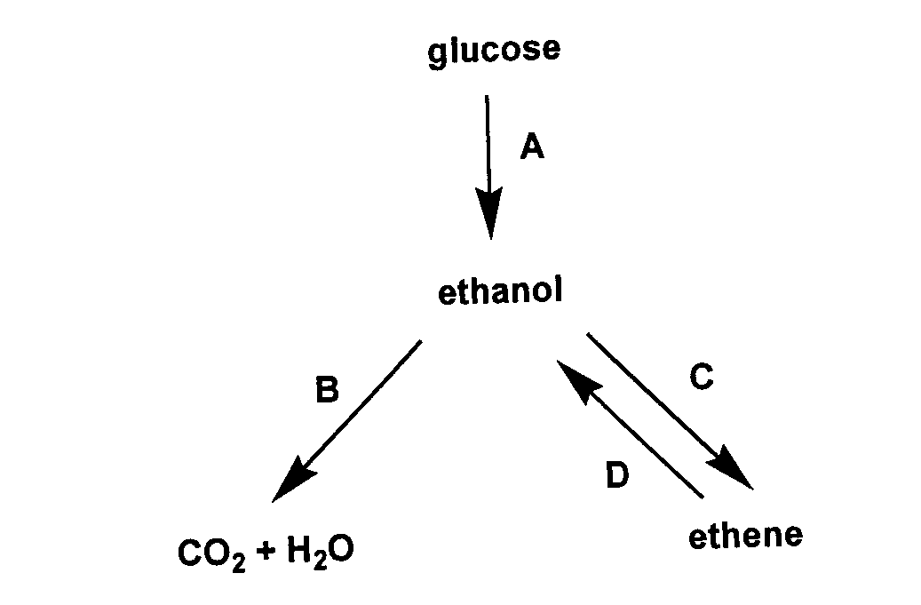

|  |  |
| --- | --- |
| **Reaction** | **Type of Reaction (4 marks)** |
| A |  |
| B |  |
| C |  |
| D |  |

|  |  |
| --- | --- |
| **Reaction** | **Chemical Equation (5 marks)** |
| A |  |
| B |  |
| C |  |
| D |  |

**Question 13 (4 marks)**

a Describe two conditions under which a nucleus is unstable (2 marks)

………………………………………………………………………………………………………………...

………………………………………………………………………………………………………………...

………………………………………………………………………………………………………………...

………………………………………………………………………………………………………………...

b What is the effect of a nucleus being unstable? (1 mark)

………………………………………………………………………………………………………………...

………………………………………………………………………………………………………………..

c Identify an instrument that could be used to detect a substance that has unstable nuclei (1mark)

………………………………………………………………………………………………………………...

**Question 14 (3 marks)**

a Give an equation (using structural formulae) for the reaction between ethylene and bromine

water and name the organic products (2 marks)

b i Identify the systematic name for styrene (1 mark)

………………………………………………………………………………………………………………...

(2marks)

ii Describe one use for polystyrene and identify a property which makes it useful for this purpose

………………………………………………………………………………………………………………...

………………………………………………………………………………………………………………...

………………………………………………………………………………………………………………...

